Exercise: Asynchronous Programming
Submit your solutions in the SoftUni judge system at:
https://judge.softuni.org/Contests/3466/Asynchronous-Programming-Exercise
Working with Remote Data
For the solution of some of the following tasks, you will need to use an up-to-date version of the local REST service, provided in the lesson’s resources archive. You can read the documentation here.

Bus Stop
Write a JS program that displays arrival times for all buses by a given bus stop ID when a button is clicked. Use the skeleton from the provided resources.
When the button with ID 'submit' is clicked, the name of the bus stop appears and the list bellow gets filled with all the buses that are expected and their time of arrival. Take the value of the input field with id 'stopId'. Submit a GET request to http://localhost:3030/jsonstore/bus/businfo/:busId (replace the highlighted part with the correct value) and parse the response. You will receive a JSON object in the format:
stopId: {
name: stopName,
buses: { busId: time, … }
}
Place the name property as text inside the div with ID 'stopName' and each bus as a list item with text:
"Bus {busId} arrives in {time} minutes"
Replace all highlighted parts with the relevant value from the response. If the request is not successful, or the information is not in the expected format, display "Error" as stopName and nothing in the list. The list should be cleared before every request is sent.
Note: The service will respond with valid data to IDs 1287, 1308, 1327 and 2334.
See examples on the next page.

Examples
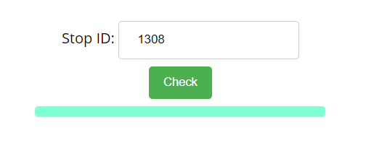
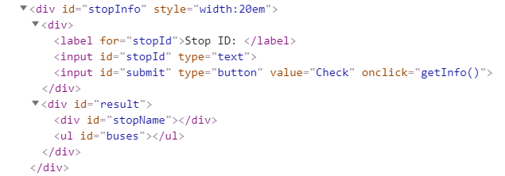
When the button is clicked, the results are displayed in the corresponding elements:
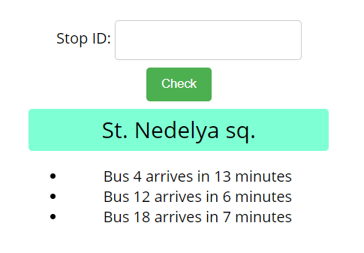
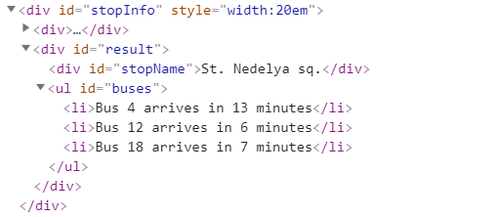
If an error occurs, the stop name changes to Error:
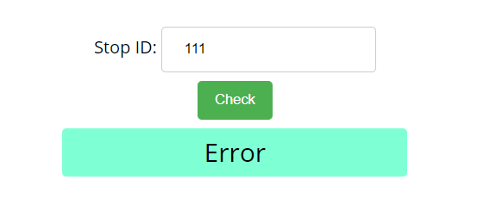
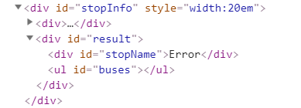

Bus Schedule
Write a JS program that tracks the progress of a bus on it’s route and announces it inside an info box. The program should display which is the upcoming stop and once the bus arrives, to request from the server the name of the next one. Use the skeleton from the provided resources.
The bus has two states – moving and stopped. When it is stopped, only the button “Depart” is enabled, while the info box shows the name of the current stop. When it is moving, only the button “Arrive” is enabled, while the info box shows the name of the upcoming stop. Initially, the info box shows "Not Connected" and the "Arrive" button is disabled. The ID of the first stop is "depot".
When the "Depart" button is clicked, make a GET request to the server with the ID of the current stop to address http://localhost:3030/jsonstore/bus/schedule/:id (replace the highlighted part with the relevant value). As a response, you will receive a JSON object in the following format:
stopId {
name: stopName,
next: nextStopId
}
Update the info box with the information from the response, disable the “Depart” button and enable the “Arrive” button. The info box text should look like this (replace the highlighted part with the relevant value):
Next stop {stopName}
When the "Arrive" button is clicked, update the text, disable the “Arrive” button and enable the “Depart” button. The info box text should look like this (replace the highlighted part with the relevant value):
Arriving at {stopName}
Clicking the buttons successfully will cycle through the entire schedule. If invalid data is received, show "Error" inside the info box and disable both buttons.

Examples
Initially, the info box shows "Not Connected" and the arrive button is disabled.
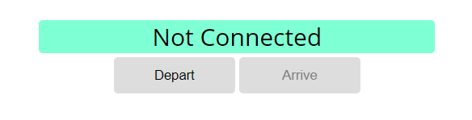
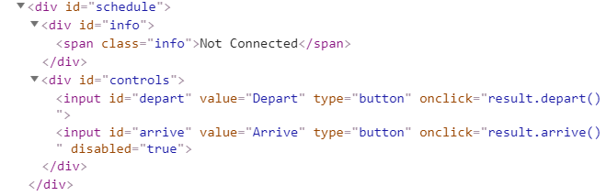
When Depart is clicked, a request is made with the first ID. The info box is updated with the new information and the buttons are changed:
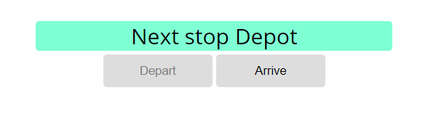
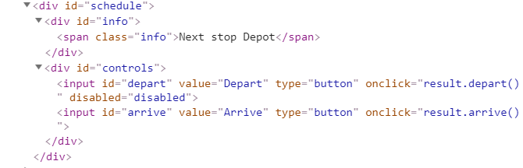
Clicking Arrive, changes the info box and swaps the buttons. This allows Depart to be clicked again, which makes a new request and updates the information:
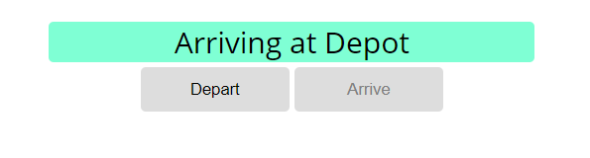
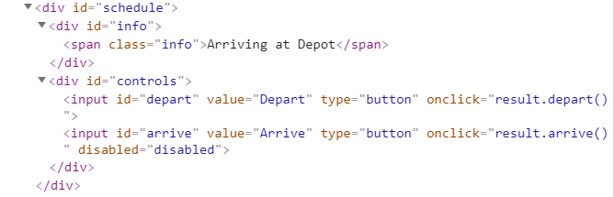

Forecaster
Write a program that requests a weather report from a server and displays it to the user.
Use the skeleton from the provided resources.
When the user writes the name of a location and clicks “Get Weather”, make a GET request to the server at address http://localhost:3030/jsonstore/forecaster/locations. The response will be an array of objects, with the following structure:
{
name: locationName,
code: locationCode
}
Find the object, corresponding to the name that the user submitted in the input field with ID "location" and use its code value to make two more GET requests:
- For current conditions, make a request to:
http://localhost:3030/jsonstore/forecaster/today/:code
The response from the server will be an object with the following structure:
{
name: locationName,
forecast: { low: temp,
high: temp,
condition: condition }
}
- For a 3-day forecast, make a request to:
http://localhost:3030/jsonstore/forecaster/upcoming/:code
The response from the server will be an object with the following structure:
{
name: locationName,
forecast: [{ low: temp,
high: temp,
condition: condition }, … ]
}
Use the information from these two objects to compose a forecast in HTML and insert it inside the page. Note that the <div> with ID "forecast" must be set to visible. See the examples for details.
If an error occurs (the server doesn’t respond or the location name cannot be found) or the data is not in the correct format, display "Error" in the forecast section.
Use the following codes for weather symbols:
- Sunny &#x2600; // ☀
- Partly sunny &#x26C5; // ⛅
- Overcast &#x2601; // ☁
- Rain &#x2614; // ☂
- Degrees &#176; // °

Examples
When the app starts, the forecast div is hidden. When the user enters a name and clicks on the button Get Weather, the requests being.
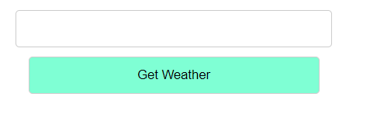
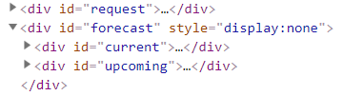
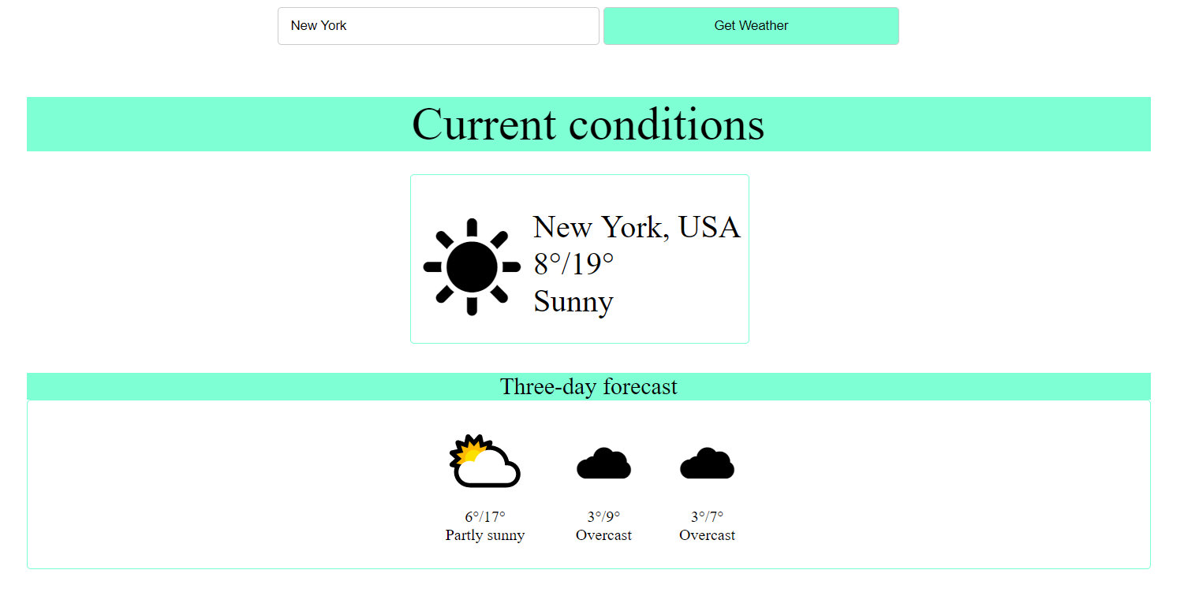
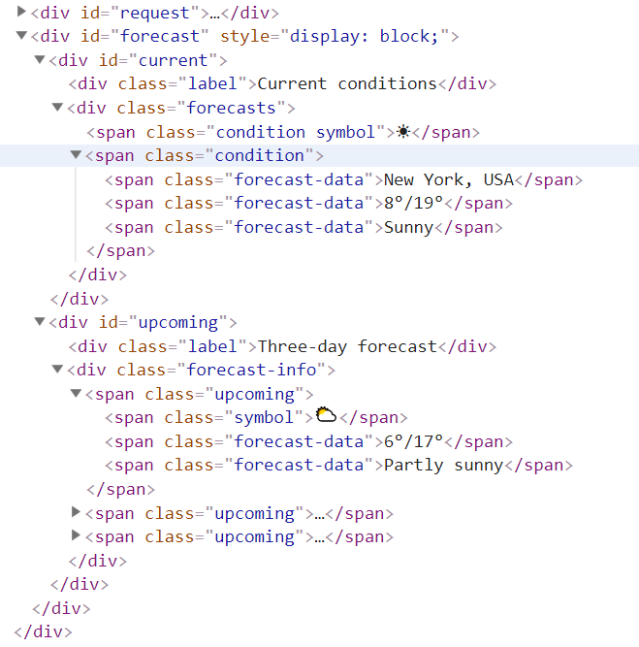

Locked Profile
In this problem, you must create a JS program which shows and hides the additional information about users, which you can find by making a GET request to the server at address:
http://localhost:3030/jsonstore/advanced/profiles
The response will be an object with the information for all users. Create a profile card for every user and display it on the web page. Every item should have the following structure:
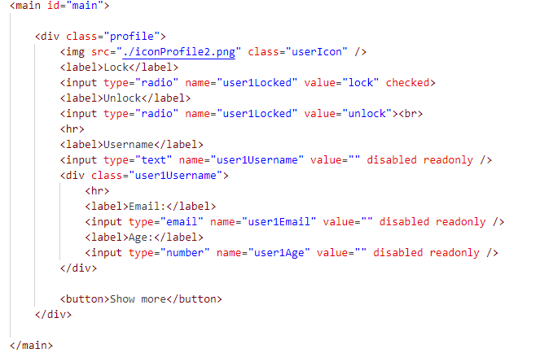
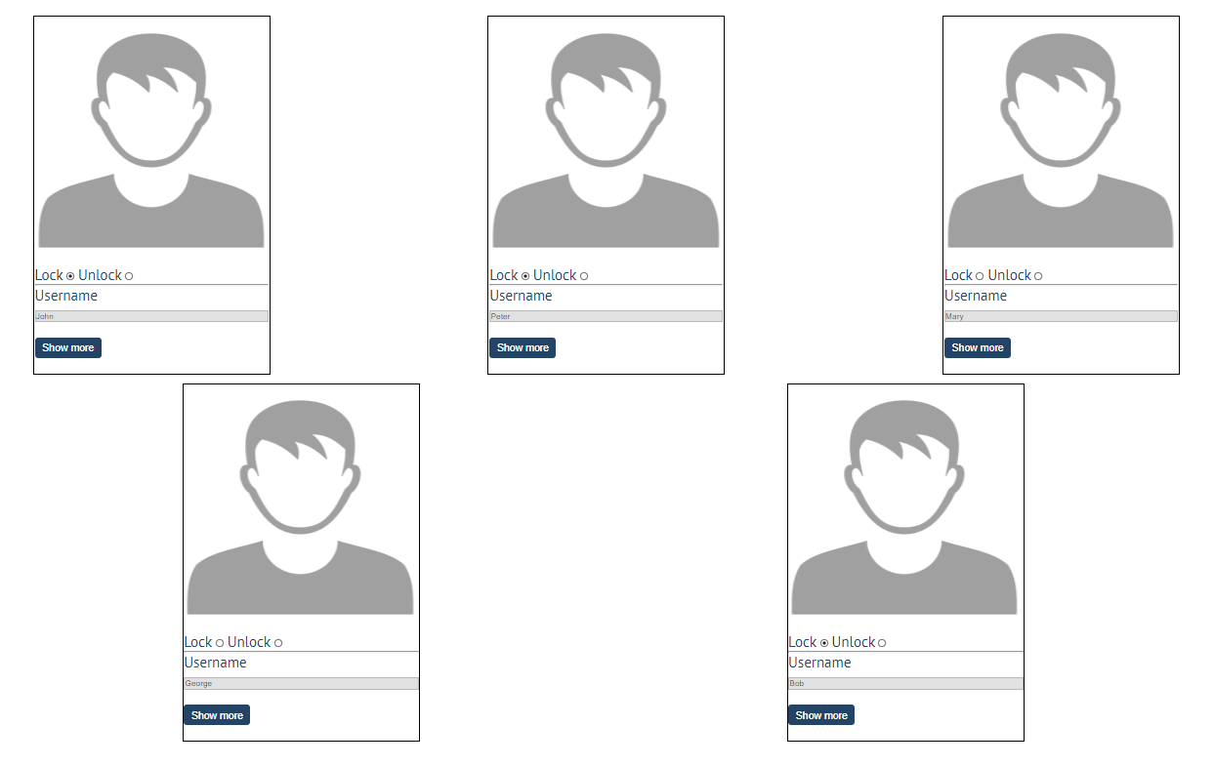
When one of the [Show more] buttons is clicked, the hiden information inside the div should be shown, only if the profile is not locked! If the current profile is locked, nothing should happen.
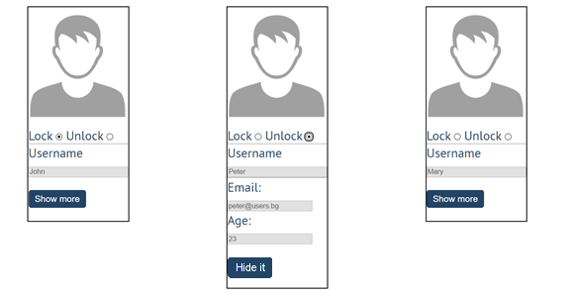
If the hidden information is displayed and we lock the profile again, the [Hide it] button should not be working! Otherwise, when the profile is unlocked and we click on the [Hide it] button, the new fields must hide again.

Accordion
An html file is given and your task is to show more/less information for the selected article. At the start you should do a GET request to the server at adress: http://localhost:3030/jsonstore/advanced/articles/list where the response will be an object with the titles of the articles.
By clicking the [More] button for the selected article, it should reveal the content of a hidden div and changes the text of the button to [Less]. Obtain the content by making a GET request to the server at adress: http://localhost:3030/jsonstore/advanced/articles/details/:id where the response will be an object with property id, title, content. When the same button is clicked again (now reading Less), hide the div and change the text of the button to More. Link action should be toggleable (you should be able to click the button infinite amount of times).
Example 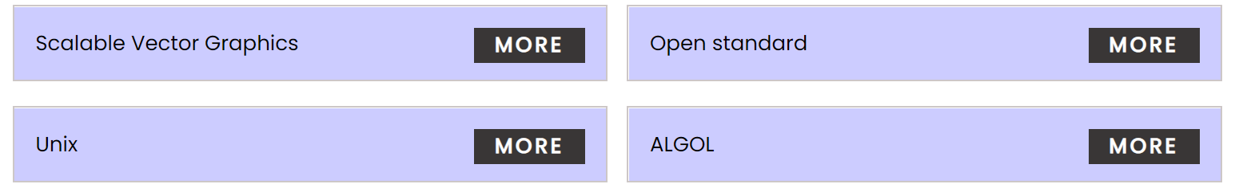
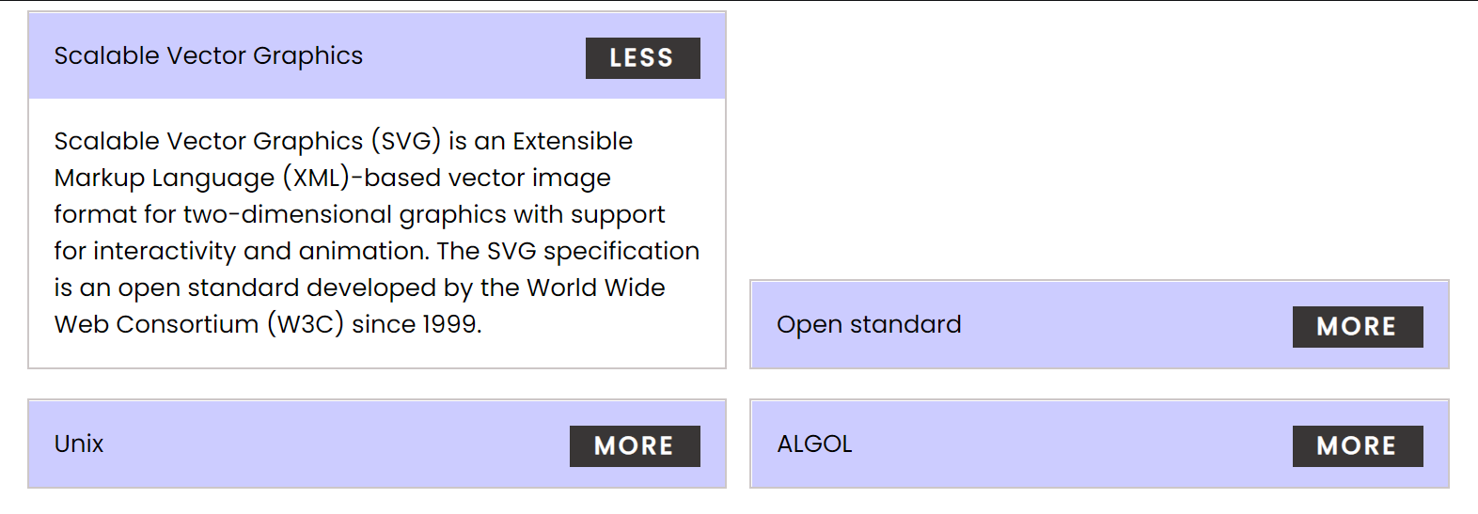
Every item should have the following structure:
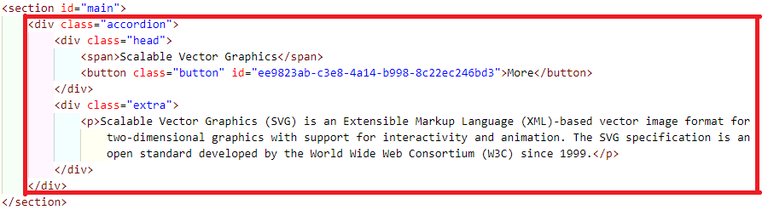
You are allowed to add new attributes, but do not change the existing ones.

Blog
Write a program for reading blog content. It needs to make requests to the server and display all blog posts and their comments.
Request URL’s:
Posts - http://localhost:3030/jsonstore/blog/posts
Comments - http://localhost:3030/jsonstore/blog/comments
The button with ID "btnLoadPosts" should make a GET request to "/posts". The response from the server will be an Object of objects.
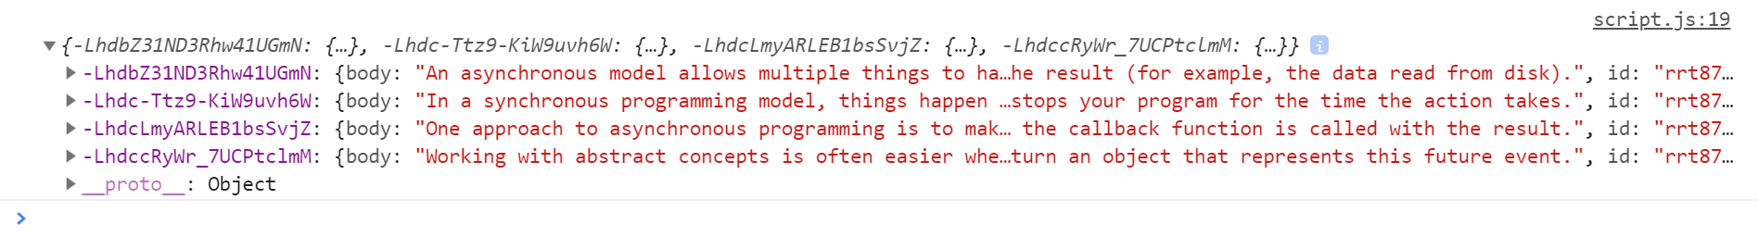
Each object will be in the following format:
{
body: {postBody},
id: {postId},
title: {postTitle}
}
Create an <option> for each post using its object key as value and current object title property as text inside the node with ID "posts".
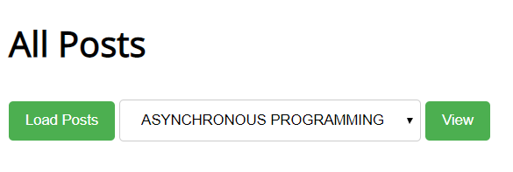
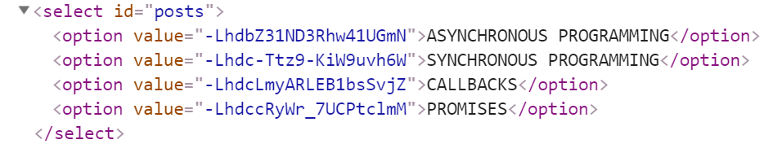
When the button with ID "btnViewPost" is clicked, a GET request should be made to:
- "/comments/:id" to obtain the selected post (from the dropdown menu with ID "posts") - The following request will return a single object as described above.
- "/comments - to obtain all comments. The request will return a Object of objects.
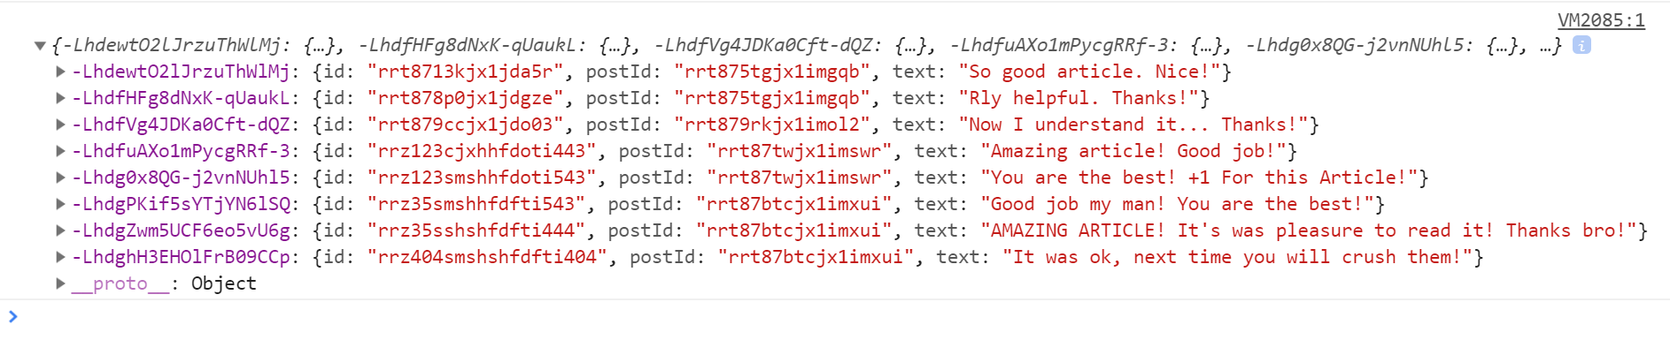
Each object will be in the following format:
{
id: {commentId},
postId: {postId},
text: {commentText}
}
You have to find this comments that are for the current post (check the postId property)
Display the post title inside h1 with ID "post-title" and the post content inside p with ID "post-body". Display each comment as a <li> inside ul with ID "post-comments". Do not forget to clear its content beforehand.
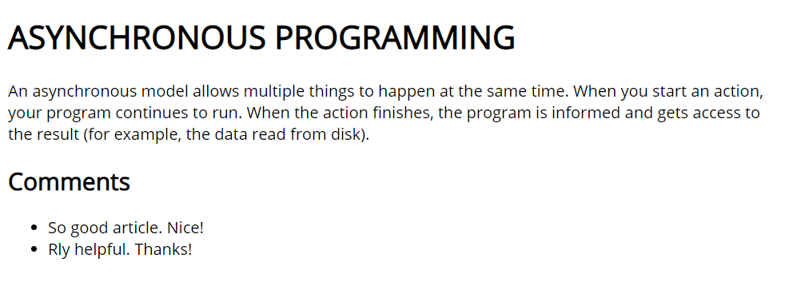
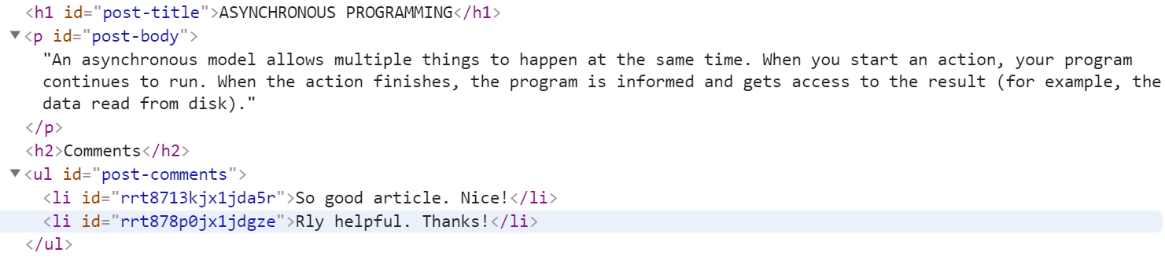

Submitting Your Solution
Place in a ZIP file the content of the given resources including your solution. Exclude the node_modules folder if there is one. Upload the archive to Judge.
